| **Title** | 2nd homework in the Python-based basic Machine learning  class by 201923250 |
| --- | --- |

| **Author** | 201923250 | **Date** | 04.15.2022 |
| --- | --- | --- | --- |

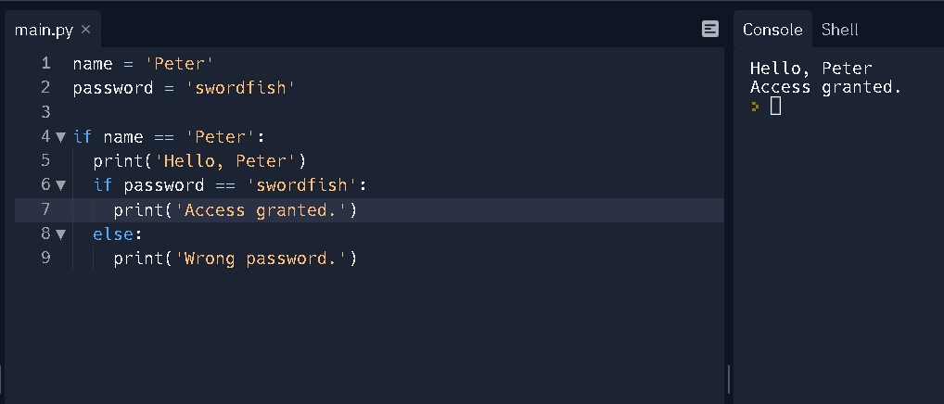

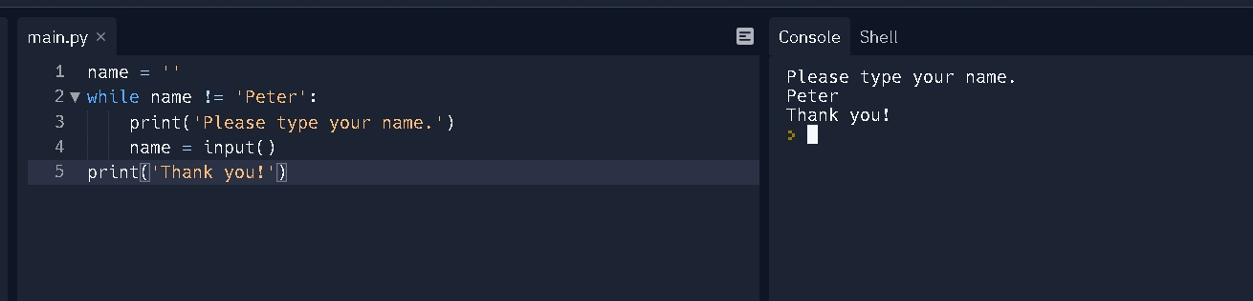

**Summarization for pages from 21 to 40**

"If the first condition is true, do this," this form of flow control structure might say in plain English. Otherwise, if the second condition is met, proceed. "If not, find something else to do." If you're using if, elif, and else statements together, keep these principles in mind to avoid bugs.

However, not all programs are run by just going straight down. If you trace through a program using flow control statements with your finger, you'll probably find yourself bouncing around the source code based on circumstances and skipping entire phrases.

Range() is one of the functions that can be called with multiple arguments separated by a comma. This allows you to adjust the integer supplied to range() to follow any sequence of numbers, including one that does not begin with zero.